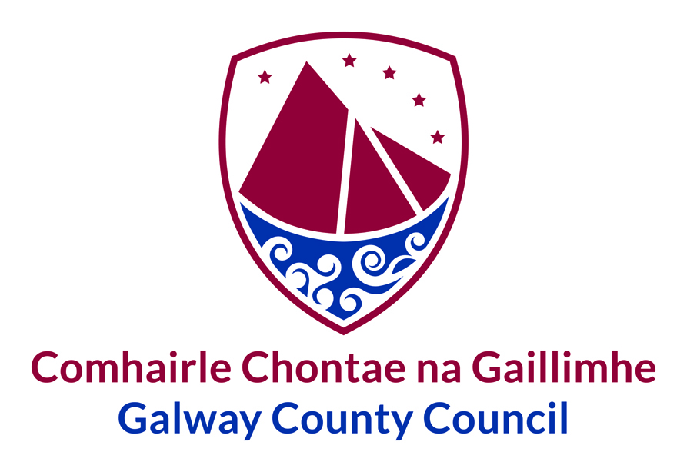

Cruinniú / Meeting

Coiste Polasaí Straitéiseach Pobal & Cultúr

Community & Culture Strategic Policy Committee (SPC)
Dé Luain 22 Meán Fómhair 2020 14:00
Tuesday 22nd September 2020 14:00

Dear SPC Member,

The third meeting of the Community and Culture SPC will take place on Tuesday the 22nd of September. The meeting will take place at 2:00pm in the Council Chamber, Galway County Council, County Hall, Prospect Hill, Galway. It will be onsite and all social distancing measures have been put in place to ensure the health and safety of SPC members and support staff.

The agenda for the meeting is as follows:
- Minutes of meeting of the Community and Culture SPC held on 16 July 2020
- Draft Public Art Policy
- Age Friendly Strategy
- AOB

I would be grateful if you could confirm attendance by return as soon as possible.

Many thanks for your co-operation.

