**POSITIVE AGEING WEEK 2021**

**27th September – 1st October 2021**

**Positive Ageing Week 2021 is an opportunity to shine a light on all the positive contributions of older people in our communities, and to create a buzz across the City and County which highlights positivity of older age.**

One part of the campaign is to showcase older people in our communities who we know to be active contributors to friends, family, neighbourhoods and communities or who epitomise healthy and active ageing.

**Do you know someone like this in your community?**

**If so, wouldn’t it be great to showcase them during Positive Ageing Week?**

Galway Age Friendly Alliance, which is a partnership of public bodies, local agencies, and representatives of older people, will host an exhibition in the Eyre Square Shopping Centre during Positive Ageing Week and showcase the bio’s of up to 20 older people from across the City & County, in addition to highlighting and promoting them on local radio and newspapers.

We are inviting you to nominate someone from your community – it’s as easy as ABC!

1. Agree who your community would like to nominate and get their permission to be put forward for the Positive Ageing Week Exhibition.
2. Write a short description overleaf of the person (no more than 200 words) describing their contribution and/or approach to healthy and active ageing
3. Return the bio to Jacquie Lynskey, Head of Senior Services at COPE Galway – [jlynskey@copegalway.ie](mailto:jlynskey@copegalway.ie) – by 5pm on 7th September 2021

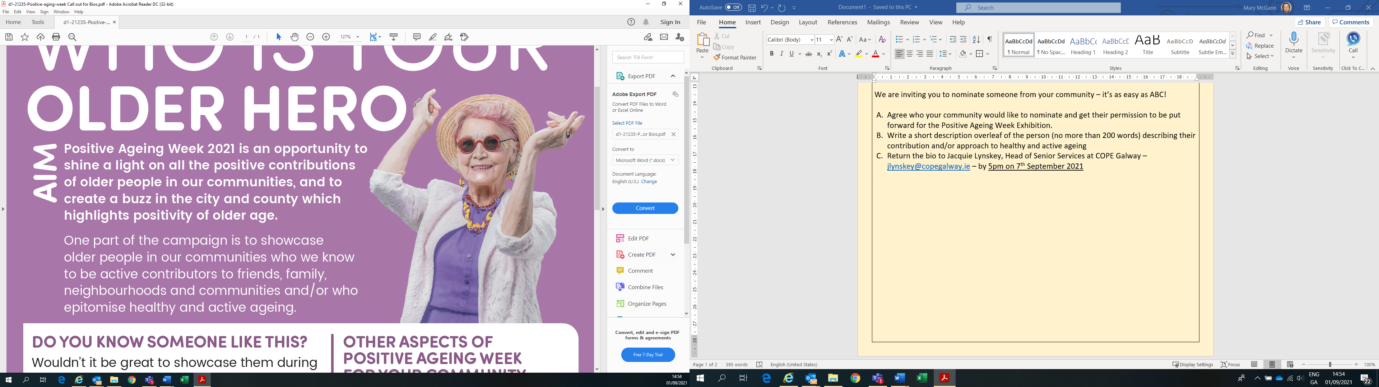  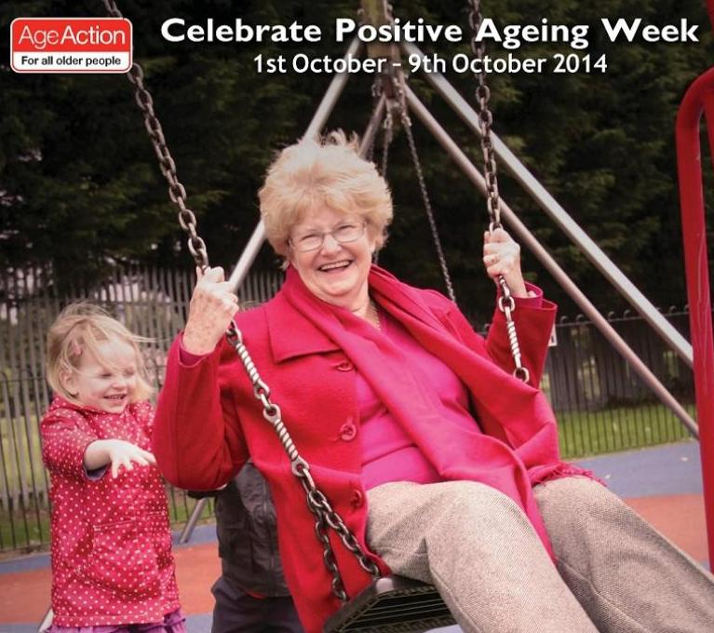

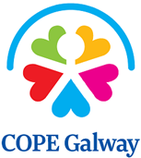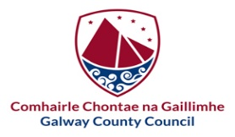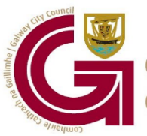

**Consent Form to take part in Positive Ageing Exhibition for Galway City & County**

**Positive Ageing Week 2021**

|  |  |
| --- | --- |
| Positive Ageing Week (27th September to 1st October 2021) is an opportunity to shine a light on the contributions of older people across our communities in Galway. By completing and signing this form, your nominee gives permission to Galway Age Friendly Alliance to use their bio and take their photo to use in our Positive Ageing Week project in 2021, and any associated communications including digital media, print media, social media, newsletters or annual reports, etc.  Thank you so much for taking part in this initiative. | |
| Name: |  |
| Location (Town/Village): |  |
| Mobile Tel No. |  |
| E-mail: |  |
| Signature: |  |
| Date: |  |



|  |  |
| --- | --- |
| Please provide a short description of the above-named person describing their approach to healthy, active and positive ageing and how they contribute to their neighbourhood and community: | |
|  | |
| Name & contact details of person from nominating Agency or Community Group: |  |

