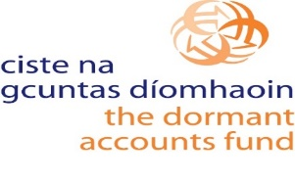
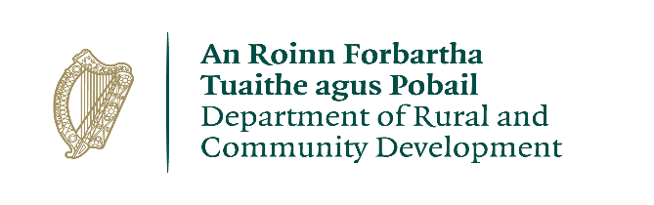

Social Enterprise Capital Grants Scheme 2021
Application Form

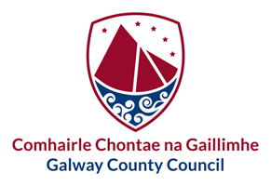
FOR OFFICE USE ONLY

Date Received:

Reference Number:

LCDC recommendation:

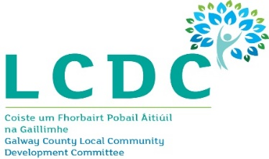

ALL APPLICATIONS ARE TO BE RETURNED TO:
communitygrants@galwaycoco.ie
by
5.00 p.m. on Friday 15th October 2021

CLOSING DATE WILL BE STRICTLY ADHERED TO.

Social Enterprise Declaration
A Social Enterprise is an enterprise whose objective is to achieve a social, societal or environmental impact, rather than maximising profit for its owners or shareholders.
It pursues its objectives by trading on an ongoing basis through the provision of goods and/or services, and by reinvesting surpluses into achieving social objectives.
It is governed in a fully accountable and transparent manner and is independent of the public sector. If dissolved, it should transfer its assets to another organisation with a similar mission.
National Social Enterprise Policy for Ireland 2019-2022

I confirm that the organisation which I represent-
Is an enterprise whose objective is to achieve a social, societal or environmental impact, rather than maximising profit for its owners or shareholders. | Yes/No: _________
Pursues its objectives by trading on an ongoing basis through the provision of goods and/or services.  Please specify what goods/service you trade on an ongoing basis: | Yes/No: _________  ________________________
Reinvests any surpluses into achieving social objectives. | Yes/No: _________
Is governed in a fully accountable and transparent manner and is independent of the public sector. | Yes/No: _________
If dissolved, it will transfer its assets to another organisation with a similar mission. | Yes/No: _________

Organisation Details

Name of Social Enterprise:

Address of Social Enterprise in County Galway:

Eircode:

Contact Person:

Role of Contact Person:
Contact Email Address:

Contact Telephone No.:

Organisation Website:

Tax Reference Number (if applicable):

Tax Clearance Access Number (if applicable)

Charity Number (if applicable)

Successful applications for funding under this programme will only be paid to the applicant organisation’s Bank Account. Please ensure you have your Bank Account details to hand if your application is successful.

Details of Proposed Expenditure

What will the funding be used for?

Why is this funding needed?
What impact would this grant have on your organisation’s service delivery.

When will the purchase be made?

Amount being applied for | €
Is this amount the partial or total cost

If partial, please give the estimated total cost | €

Important note: Please include supporting documentation, i.e. 2 estimates/quotes from different independent suppliers with this form.
Please state how your social enterprise proposes to acknowledge the Dormant Accounts Fund (DAF), DRCD, Local Authority and LCDC
Note: Depending on the amount being applied for, this could be as simple as including an acknowledgement on equipment labels, or on notices/signs, or in any newsletters that are being produced locally.

In order to process your application, it may be necessary for Galway County Council to collect Personal information from you. Such information will be processed in line with our privacy statement which is available to view here: http://www.galway.ie/en/services/yourcouncil/privacystatement/

I confirm I have read and fully understand the Terms and Conditions of this Programme. | Yes/No: _________
I confirm that I have read and fully understand the ‘Statement on Public Finances’ contained in Appendix A. | Yes/No: _________

I declare that the information provided by me on this application form is truthful and complete.

Signed: _________________________________ Date:_________________________

Print Name: ______________________________

Position in Organisation: ____________________________(Must be Chairperson or CEO/MD)

For Official Use only:
I verify that the application has been completed fully and that the applicant organisation meets the definition of a Social Enterprise under the National Social Enterprise Policy for Ireland 2019-2022.
Signed: _____________________________________________
LCDC: _______________________________________________
Date: ________________________

Guidance for Applicants

Background
In July 2019, the Department of Rural and Community Development published a National Social Enterprise Policy for Ireland. The Social Enterprise Capital Grants Scheme 2021 is one initiative being taken by the Department of Rural and Community Development under the Policy to support social enterprises and is complementary to other supports provided by the Department. It is anticipated that the small scale nature of the grants under this scheme will particularly benefit smaller or start-up social enterprises which do not necessarily have the capacity to compete for larger grants, but which nonetheless have a need for upgraded/additional equipment to help them to deliver their services. The scheme is being administered on behalf of the Department of Rural and Community Development by the network of Local Community Development Committees (LCDCs) across the country. The deadline for receipt of completed applications is 5.00 p.m. on Friday 15th October 2021.

Eligible Organisations
Only social enterprises, as defined in the National Social Enterprise Policy (see below), may apply under this scheme. All applicants will be checked and verified to ensure they meet the definition. Applicants who do not meet this definition will not be considered.
A Social Enterprise is an enterprise whose objective is to achieve a social, societal or environmental impact, rather than maximising profit for its owners or shareholders.
It pursues its objectives by trading on an ongoing basis through the provision of goods and/or services, and by reinvesting surpluses into achieving social objectives.
It is governed in a fully accountable and transparent manner and is independent of the public sector. If dissolved, it should transfer its assets to another organisation with a similar mission.
National Social Enterprise Policy for Ireland 2019-2022

Funding Allocation
Amounts approved to social enterprises will be subject to the total number of applications approved and the overall budget available (€30,533.17). [It is envisaged that any individual grants will not exceed €5,000.]

Eligible Costs
Under this scheme, grants will be provided to social enterprises towards small scale capital costs. Capital costs incurred by social enterprises for the purchase of equipment are eligible. Repairs and refurbishment of existing facilities can also be funded. The scheme does not provide funding for operating costs (e.g. the employment of staff, electricity costs, heating costs, etc.) or administrative costs. Only expenditure incurred after the date of grant approval will be eligible.
The grant may cover all, or part of, the purchase or works in question. However, the full cost of the purchase or works must be provided on the Application Form.

Assessment Criteria
Applicants will be required to confirm that their organisation meets the definition of a social enterprise as set out in the National Policy. Applicants will be asked to explain the purpose for which the grant is sought. Factors such as demonstratable need and the potential impact of the grant on service delivery will also be taken into account.

Applications
All applications will be reviewed by the LCDCs to verify that the applicant meets the definition of a social enterprise as set out in the National Social Enterprise Policy for Ireland. Final decisions on funding approvals will be made by the Department of Rural and Community Development.
Applicants will be notified of the outcome via the relevant LCDC in mid-November. Successful applicants will have until 8 April 2022 to draw down the grant, based on evidence of completed purchases or works.

Terms and Conditions
- Only social enterprises as defined by the National Social Enterprise policy will be eligible for funding under this scheme.
- The information supplied by the applicant must be accurate and complete. Incomplete applications will not be considered for funding.
- Misinformation may lead to disqualification and/or the repayment of any grant made.
- All information provided in respect of the application for a grant will be held electronically. The Department reserves the right to publish a list of all grants awarded on its website.
- The Freedom of Information Act applies to all records held by the Department of Rural and Community Development and Local Authorities.
- The application must be signed by the Chairperson or CEO/MD of the social enterprise.
- It is the responsibility of each social enterprise to ensure that it has proper procedures and policies in place including appropriate insurance where relevant.
- Evidence of expenditure, receipts / invoices must be retained and provided to the LCDC or their representative if requested.
- The Dormant Accounts Fund and the Department of Rural and Community development must be publicly acknowledged in all materials associated with the purpose of the grant.
- Generally no third party or intermediary applications will be considered.
- Late applications will not be considered.
- Applications in any form should arrive not later than the closing date.
- Claims that any application form has been lost or delayed in the post will not be considered, unless applicants have a Post Office Certificate of Posting in support of such claims.
- Breaches of the terms and conditions of the grants scheme may result in sanctions including disbarment from future grant applications.
- By completing this Application Form, you consent to the data on the form, as required, being transferred to the Department of Rural and Community Development to enable a decision to be made on your application.
- Successful applicants may be subject to audit by the LCDC or the Department of Rural and Community Development.
- Documentation relating to the purchase of equipment or the completion of works should therefore be maintained for inspection for a period of 7 years.

Enquiries
Applicants will be advised that all enquiries in relation to the Social Enterprise Capital Grants Scheme 2021 should be directed to communitygrants@galwaycoco.ie

APPENDIX A

Statement on Public Finances

This Statement should be brought to the attention of every grant receiving body

If you are in receipt of public funding you should

Clarity  Understand the purpose and  conditions of the funding and the  outputs required  Apply funding only for the business  purposes for which they were  provided  Apply for funding drawdown only  when required for business purposes  Seek clarification from the grantor  where necessary – on use of funds,  governance and accountability  arrangements | Governance  Ensure appropriate governance  arrangements are in place for:  Oversight and administration of funding  Control and safeguarding of funds from  misuse, misappropriation and fraud  Accounting records which can provide, at any time, reliable financial information  on the purpose, application and balance remaining of the public funding  Accounting for the amount and source of the funding, its application and  outputs/outcomes
Value for Money  Be in a position to provide evidence on:  Effective use of funds  Value achieved in the application of funds  Avoidance of waste and extravagance | Fairness  Manage public funds with the highest  degree of honesty and integrity  Act in a manner which complies with  relevant laws and obligations (e.g. tax,  minimum wages)  Procure goods and services in a fair and  transparent manner  Act fairly, responsibly, and openly in your  dealings with your Grantor

