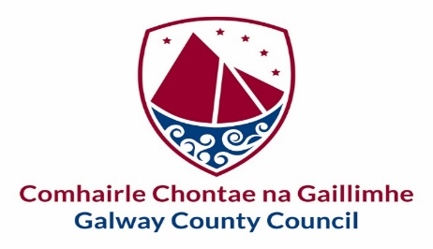

Comhairle Contae na Gaillimhe  Gradaim an Chathaoirligh  2022 | Galway County Council  The Cathaoirleach’s Awards  2022
Tá an fhoirm seo le fáil i gcló mór chomh maith | This form is also available in large print
Tá leagan Gaeilge den fhoirm seo ar fail ach í a iarraidh
Tá míle fáilte an fhoirm seo a líonadh i nGaeilge

Please Read the Information Sheet Carefully Before Completing this Form
www.galwaycountyppn/awards.ie
Please type your answers.

Nomination Form for Groups

Please state the name of the Group who is being nominated:

Please confirm the Town/Village the Group represents and the Municipal District in which it is located: | Athenry-Oranmore ☐ Ballinasloe ☐ Conamara ☐ Loughrea ☐ Tuam ☐  Please tick one box only

Please confirm the category in which your entry is being made:  (Please tick one box only) | Arts & Culture ☐  Best Contribution to Heritage ☐  Best Contribution to the Irish Language ☐  Environment & Climate Action ☐  Heritage Publication ☐  Social Inclusion ☐  Sports ☐

DETAILS OF GROUP BEING NOMINATED:

Name of Group being nominated:
Contact Person for Group:

E-mail address for Contact Person:
Telephone No. for Contact Person:
Any Website / Social Media Address of Group:
Is the Group a member of Galway County PPN? | Yes ☐ No ☐
How is the Group funded?

Number of Paid Staff in the Group:
Number of Volunteers in the Group:
How are the above staff/volunteers structured to deliver the aims of the Group?

How does the Group interact with other Groups in the Community?
How does the Group engage with and encourage people in the community to become involved with their activities?
Please summarize in bullet points the main achievements of the Group:

DETAILS OF NOMINATED ACTIVITY / PROJECT:

Please describe the project or activity undertaken by the Group in the selected category area in 2021/22, how it has been planned and organized, and outline how it has been of benefit to the community and why you feel it deserves an Award:
Please outline any future plans of the Group and how these will grow and sustain their activities/project and be of future benefit to the community (including mitigating the effects of COVID-19):
Please provide links to any supporting documentation regarding the activities/project, e.g. social media photos, videos, etc. (optional)

DECLARATION OF NOMINATING GROUP OR THIRD-PARTY INDIVIDUAL:

I declare that the information given in this form is true and complete to the best of our knowledge. I agree to the processing and disclosure of information by Galway County Council and Galway County PPN to other third parties for the judging process, and further consent to the disclosure of relevant information or images for the purpose of marketing or promotion of these Awards.

I confirm that the Nominated Group are aware and in agreement with their nomination.

I agree to accept the decision of the assessment of the nominations for The Cathaoirleach Awards as final.

Signed:
Name:
Relationship / Link to Nominated Group / Organisation:

Date:
Mobile Phone No. in case further contact is required to clarify details:

