
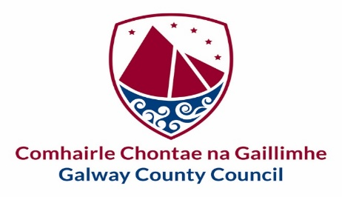

Comhairle Contae na Gaillimhe  Gradaim an Chathaoirligh  2022 | Galway County Council  The Cathaoirleach’s Awards  2022
Tá an fhoirm seo le fáil i gcló mór chomh maith | This form is also available in large print
Tá leagan Gaeilge den fhoirm seo ar fail ach í a iarraidh
Tá míle fáilte an fhoirm seo a líonadh i nGaeilge

Please read the Guidance Notes before completing this Nomination Form
www.galwaycountyppn/awards.ie
Please type your answers.

Nomination Form for Individual Volunteer of the Year

Please state the name of the Individual who is being nominated:

This form should be used to nominate an Individual in recognition of
their significant contribution to Community & Voluntary life in County Galway
Please read the accompanying terms & conditions and judging criteria before completing the form.

DETAILS OF INDIVIDUAL BEING NOMINATED
Name of Individual being nominated:
E-mail address:

Telephone No.:

Is the Individual a member of a PPN Registered Group in the County? | Yes ☐ Name of Group: _________________________ No ☐ Don’t know ☐
What community/parish does the individual cover in their voluntary work?
For background purposes, please describe how this Individual has engaged with the local community over the years in the course of their voluntary work and outline their main achievements:
Please describe the voluntary work of the Individual in 2021/2022 and how it has benefited individuals and the wider community:
Explain why you think the Individual deserves to win a Volunteer of the Year Award:
Please provide links to any supporting documentation regarding their activities in the community:

DECLARATION OF NOMINATING GROUP OR THIRD-PARTY INDIVIDUAL:
Name of Group or Third-Party Individual making the nomination:
E-mail address:

Telephone No.:

What is your link/relationship to the Individual you are nominating?

I declare that the information given in this form is true and complete to the best of my knowledge and agree to the processing and disclosure of information by Galway County Council and Galway County PPN to other third parties for the judging process, and further consent to the disclosure of relevant information by these parties relating to the marketing or promotion of the Awards.

I confirm that the Nominated Individual is aware and in agreement with their nomination for the Awards and agree to accept the decision of the judging panel for the nominations as final.

Signed on behalf of nominating Group or Third-Party Individual:
Name (in block capitals):
Signed:
Group / Organisation:

Date:

